Installation and Navigation of Visual Studio Code (VS Code) Instructions: Answer the following questions based on your understanding of the installation and navigation of Visual Studio Code (VS Code). Provide detailed explanations and examples where appropriate.

Questions:

1. Installation of VS Code:
   * Describe the steps to download and install Visual Studio Code on Windows 11 operating system. Include any prerequisites that might be needed.

Go to the VS code official website.

Go to downloads

Download the option for mac

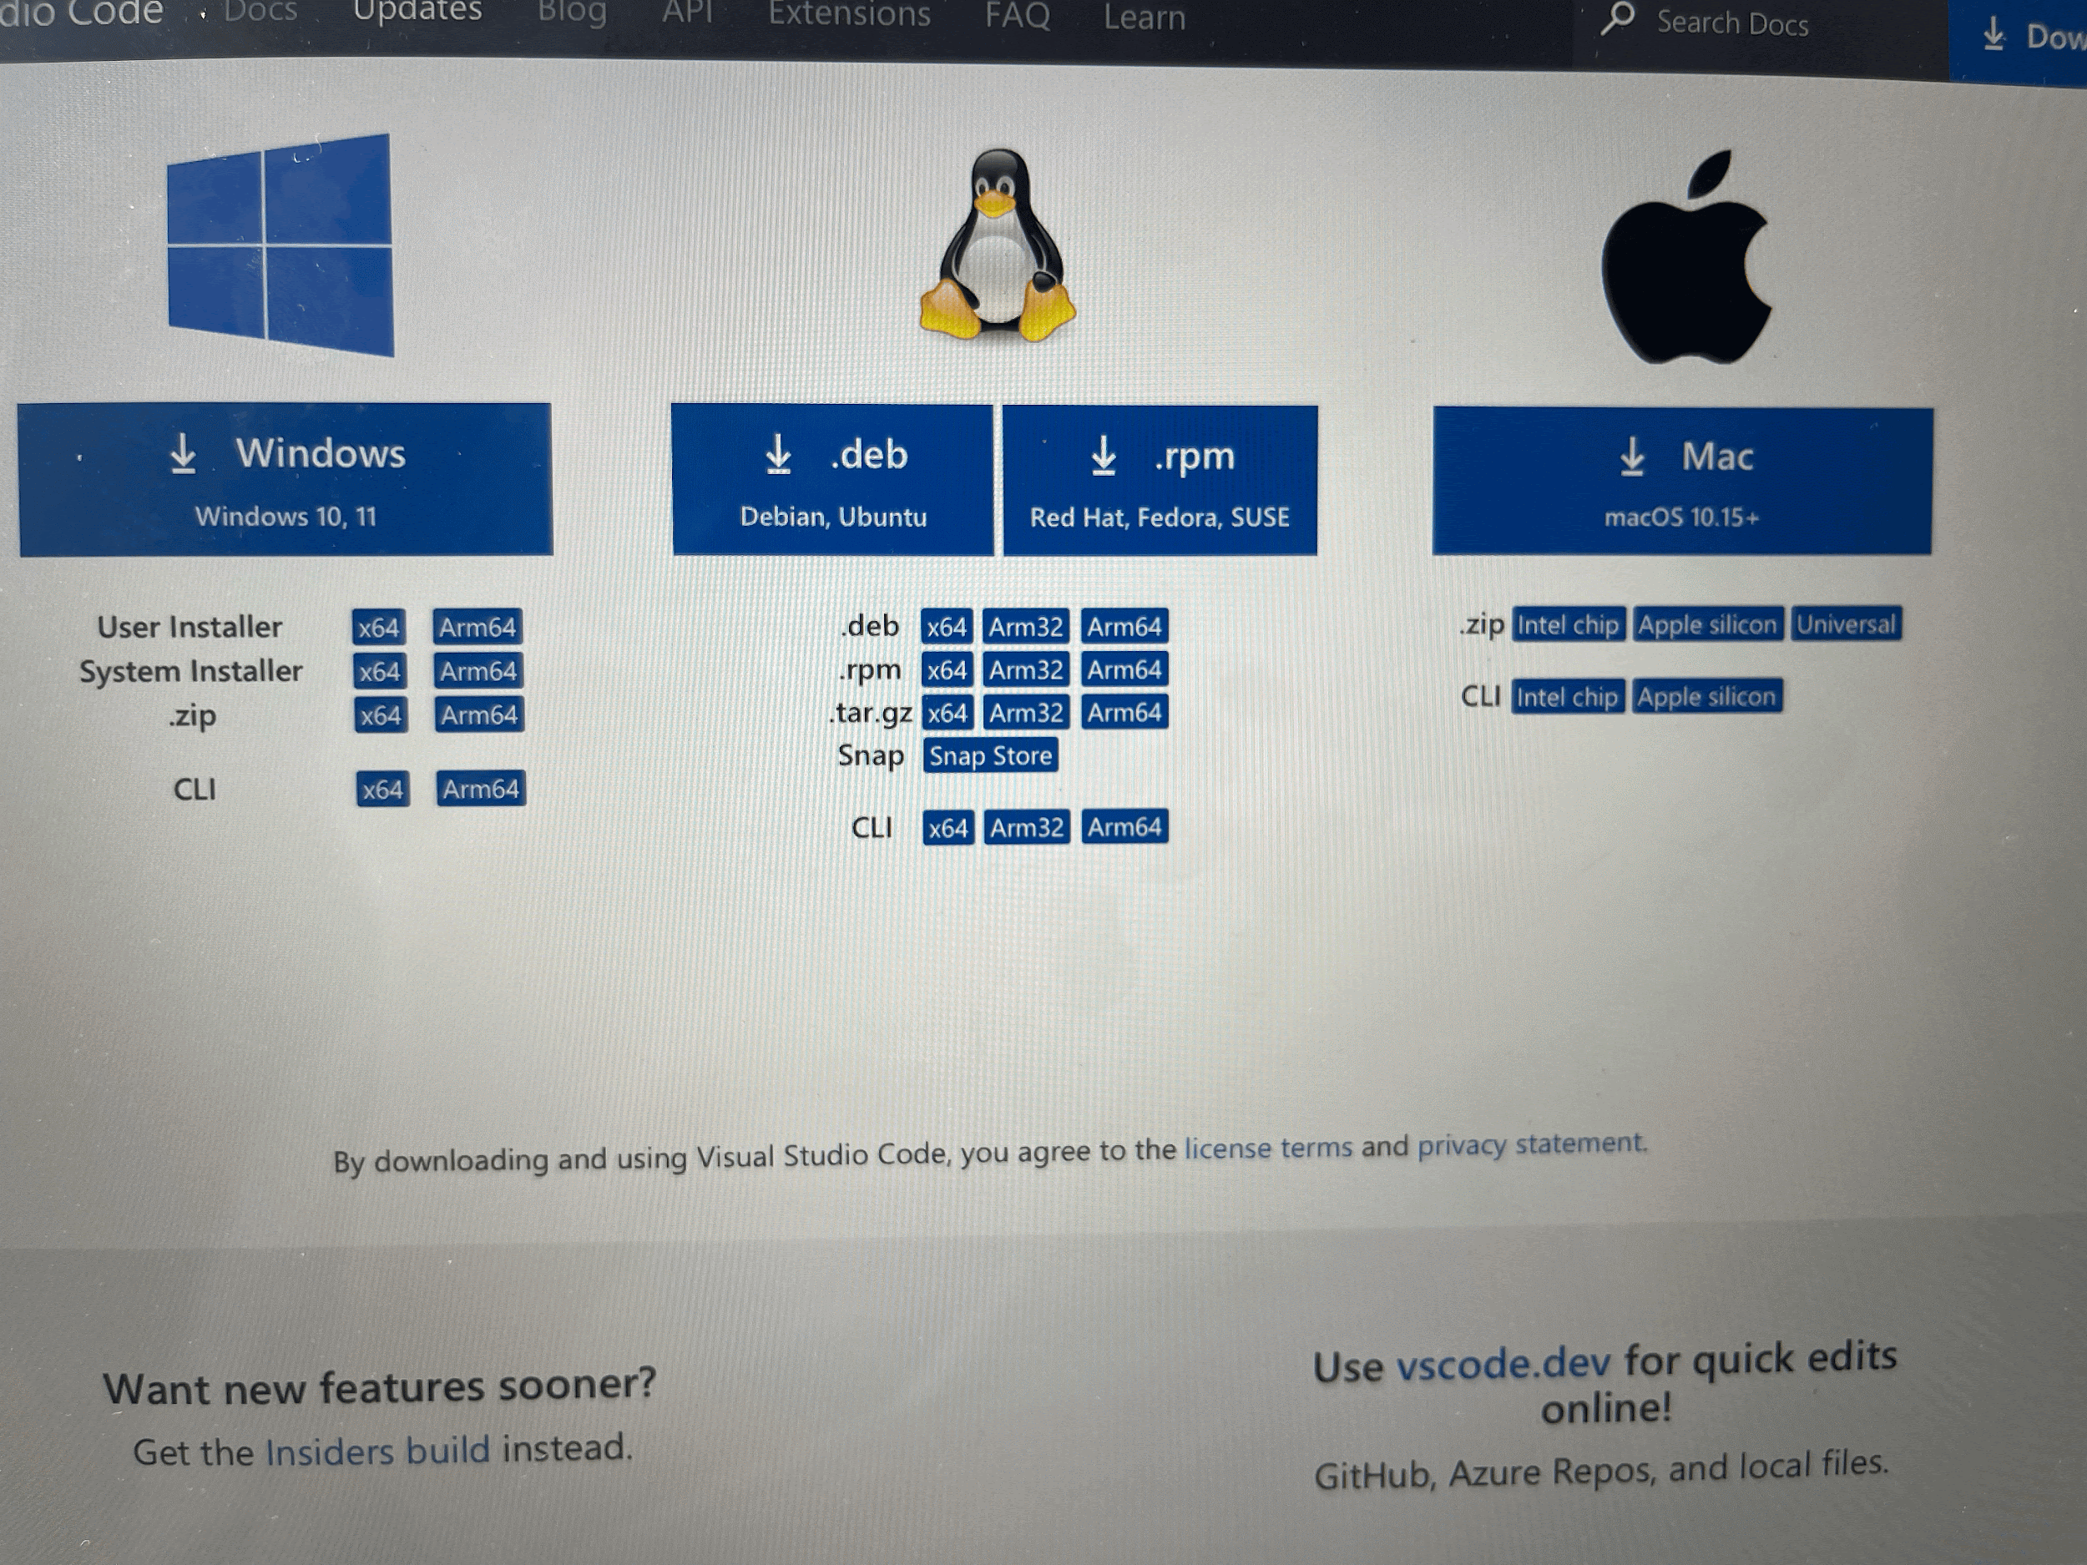

When it downloads, double click to extract the VS code app from the .zip file, and then drag it into applications. You can then open it from there

1. First-time Setup:
   * After installing VS Code, what initial configurations and settings should be adjusted for an optimal coding environment? Mention any important settings or extensions.

After installing VS code, you need to configure it such that it can be opened from the mac terminal. To do this, press Command + Shift + P to open the Command Palette. Then type Shell Command: Install 'code' command in PATH. this will allow you to open VS code from the mac terminal

You will also need to install some extensions, such as Coderunner, python, pylance, python debugger, dart and flutter.

1. User Interface Overview:
   * Explain the main components of the VS Code user interface. Identify and describe the purpose of the Activity Bar, Side Bar, Editor Group, and Status Bar.

Activity Bar is located on the far left side of the window. It allows you to switch between different views and provides access to essential features i.e. explorer, Search, Source Control, Run and Debug, and Extensions

The sidebar shows various icons depending on what is selected in the activity bar. For example, if you select the explorer icon on the activity bar, you will access the files and folders you are working on. If you click on search, you will be able to type into the search box that appears in the sidebar.

The editor group is the central area on the window where you write or edit your code.

The status bar is the area at the bottom of the window which displays information about the current state of the editor and the open project. It also shows which branch one is working in

4. Command Palette:

* + What is the Command Palette in VS Code, and how can it be accessed? Provide examples of common tasks that can be performed using the Command Palette.

The command palette is a feature that allows you to access various commands on VS code. It is accessed on mac by going to view then the command palette, or by pressing command+shift+P. Using the command palette, you can change the colour theme, install extensions, and create new files, among many other actions.

5. Extensions in VS Code:

* + Discuss the role of extensions in VS Code. How can users find, install, and manage extensions? Provide examples of essential extensions for web development.

Extensions are used to improve the functionality of VS code. By adding extensions, one can customize the coding environment to suit various programming languages and frameworks, and add tools that make coding easier.

One can find extensions by clicking the extensions icon on the activity bar, and then searching for the required extension. Once you find it, click on the install button and wait for the installation process to complete. Examples of essential extensions are Python, Pylance, Coderunner, Dart and Flutter.

6. Integrated Terminal:

* + Describe how to open and use the integrated terminal in VS Code. What are the advantages of using the integrated terminal compared to an external terminal?

In Mac, you can access the terminal by clicking terminal on the top menu, then “new terminal”. The built-in terminal allows you to run your code without having to switch between applications. Also when you open in the terminal it allows you to work in the directory you are using without having to type and specify the directory manually

7. File and Folder Management:

* + Explain how to create, open, and manage files and folders in VS Code. How can users navigate between different files and directories efficiently?

In VS code, you can open files and folders by clicking on the file on the top menu, then open file or open folder. Alternatively, you can do the same by clicking on the new file or new folder icon on the explorer tab. You can navigate between the files using the explore tabs which show the folder you are working in and the files inside it.

8. Settings and Preferences:

* + Where can users find and customize settings in VS Code? Provide examples of how to change the theme, font size, and keybindings.

To access the settings, you go to “code’ on the top menu, then click on settings (on mac). A window will appear titled “settings”, and there you can search ‘font’, ‘theme’ or ‘keybindings’ to make the necessary changes

9. Debugging in VS Code:

* + Outline the steps to set up and start debugging a simple program in VS Code. What are some key debugging features available in VS Code?

To debug in VS Code, open your project and set up a launch configuration. Add breakpoints by clicking next to lines of code and start debugging with F5. Use the Debug Console and Toolbar to control the program.

10. Using Source Control:

* + How can users integrate Git with VS Code for version control? Describe the process of initializing a repository, making commits, and pushing changes to GitHub.

Open your project and click on "Initialize Repository" in the Source Control tab This sets up Git for your project. Next, you can stage your files, write a commit message, and save your changes. Connect your local project to GitHub by adding the repository URL, then push your changes to GitHub using the push button in the Source Control view.

Submission Guidelines:

* Your answers should be well-structured, concise, and to the point.
* Provide screenshots or step-by-step instructions where applicable.
* Cite any references or sources you use in your answers.
* Submit your completed assignment by 1st July